RUSIZI DISTRICT
SUBJECT: …………………………………………
Date: ……/10/2026
Time: …………………………….
Class: …………………………..
ACADEMIC YEAR: 2026 - 2027
MAX :…………../50 MARKS
Email: ceprusizi2025@gmail.com



Social and Religious Studies(SRS)
MID -TERM ONE TEST
Read all instructions carefully before you begin answering the questions.
Write your index number and your name clearly in the space provided.
Do not write anything outside the answer spaces provided.
Use blue or black ink only.
Do not use a pencil except for diagrams where necessary.
Ensure your handwriting is neat and legible.
Manage your time well to attempt all questions.
No cheating or communication with other candidates is allowed.
Any form of examination malpractice will lead to disqualification.
When you finish, check your work carefully before submitting.

SECTION A : OBJECTIVES QUESTIONS (ATTEMPT ALL QUESTIONS)
- Answer using true or False (5 marks)
- Wild fauna live freely in forests………………………………
- Planting trees cannot help control bad weather. ………..
- Humidity means water vapor in the air……………………..
- Rain fills rivers and lakes. ……………………………………..
- Infrastructure includes roads and bridges…………………
- Write the correct answer in the below blank space ( 5 marks)
  - Pre-colonial Rwanda is also called………………………………………………………………….a.Traditional b.Modern c.Colonial d.Industrial
  - The ruler was the …………………………………………..……………………………… a.President b.King c.Mayor d.Prime Minister
  - Houses were called …………………………………………………………………
a.Urugo b.Apartments c.Castles d.Palaces
  - Cattle were used for ……………………………………………………………………….…a.gifts b.milk c.cars d.furniture
  - Chiefs helping the king included except………………………. a.Land b.Military c.Cattle Teachers
- Choose the correct answer from the brackets and re-write it( 5 marks)
- (Malaria / TV): ………………………..spreads from mosquitoes.
- (Hand washing / Sleeping): …………………..prevents infections.
- (Community / Individual):……………..clean-up promotes unity.
- (Chlorine / Sand): Adding ………………..to water kills germs.
- (Brushing / Lying): ……………………….teeth prevents tooth decay
- Re-write the correct answer
- Swamps help to …………………………………………………….
- Increase floods B. Stop floods C. Burn forests D. Cause erosion
- A wind vane shows…………………………………………………
A. Wind direction B. Wind speed C. Rainfall D.sunshine
- River Nyabarongo is………………………. the river in Rwanda.
A. Shortest B. Deepest C. Longest D. Smallest

- Deforestation means……………………………………
  - Planting trees B. Cutting trees C. Growing crops D. Watering plants Answer:
- Think and find the suitable answers in the blanks below ( 5 marks)
  - Population density =……………………………….÷……………..
  - Dense population means ………………………………people live in an area.
  - Sparse population occurs when……………………..people live in an area.
  - Population explosion is a……………………………..increase in population.
  - Optimum population occurs when population …………………………………………..resources.
- What does landlocked mean? ( 1 mark)
………………………………………………………………………….................................................................................................
- Name the largest country in East Africa.(1 mark)
…………………………………………………………………………..
- Just put a circle on the correct answer( 5 marks)
- DRC borders Rwanda to the (west / south).
- Census means (counting people / drawing maps).
- Administrative map shows (politics / weather).
- Burundi borders Rwanda to the (south / north).
- Rwanda’s total area is measured in (km² / kg).
- Tick good behaviors and cross bad behaviors ( 6 marks)

Situation | Good Choice | Bad Choice
Helping others | ☐ | ☐
Lying to friends | ☐ | ☐
Forgiving others | ☐ | ☐
Fighting | ☐ | ☐
Praying to God | ☐ | ☐
Respecting others | ☐ | ☐
- Sanctity of Life teaches us………………………………………..
- To protect all life (b) To pray (c) To judge others (d) To fight ( 1 MARK)
- Choose the best answer ( 10 marks)
- God’s revelation means:
A. God hiding Himself B. God showing His will C. Human ideas
D. Nature only
- God called Abraham to:
A. Fight wars B. Build cities C. Leave his land D. Become king
- God revealed the Law to:
A. David B. Moses C. Noah D. Paul
- Nature is an example of:
A. Special revelation B. False teaching C. General revelation D. Idolatry
- Holy Scriptures are part of:
A. General revelation B. Human laws C. Special revelation D. Traditions
- God being all-powerful means He is:
A. Omniscient B. Omnipresent C. Omnipotent D. Eternal
- God being everywhere means He is:
A. Holy B. Omnipresent C. Just D. Loving
- Worshipping idols is called:
A. Faith B. Obedience C. Idolatry D. Prayer
- Friendship is based on:
A. Fear B. Violence C. Trust and love D. Lies
- Lying and gossip show:
A. Healthy friendship B. Unhealthy friendship C. Faith D. Obedience
- Name the lake below made when crater is filled by water and give an example of it that we have in Rwanda. ( 2 marks)
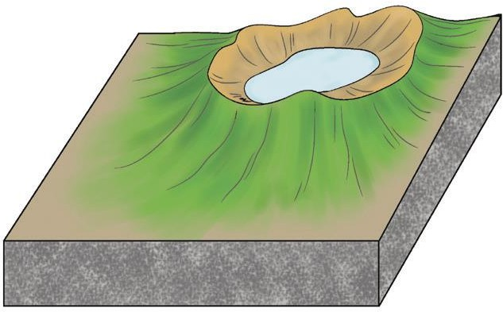
……………………………………………………..
END!!!!!!!!!!!!!!!!!

